Profitability ratios
Ratio | Rough definition/Description | Formula | Good/Target | Acceptable/Contextual | Poor/Warning
Gross Profit Margin (GPM) | The proportion of sales revenue remaining after deducting the Cost of Goods Sold (COGS). Measures direct efficiency and pricing power. | 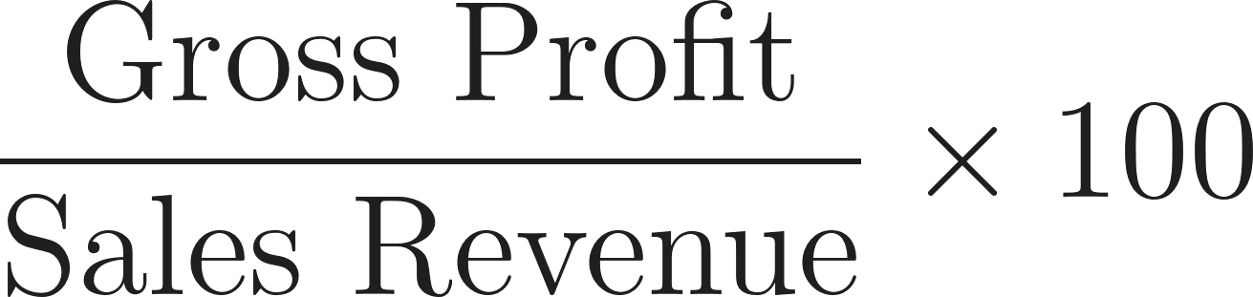 |  (High margin suggests strong pricing power or very low input costs, e.g., luxury goods/software). |  (Common for manufacturing/retail where input costs are significant). |  (Low margin means severe price competition or rising COGS; very difficult to cover fixed costs).
Profit Margin (PM) | The proportion of sales revenue remaining after deducting all expenses (COGS and overheads). Measures overall operational efficiency and the final 'bottom line.' | 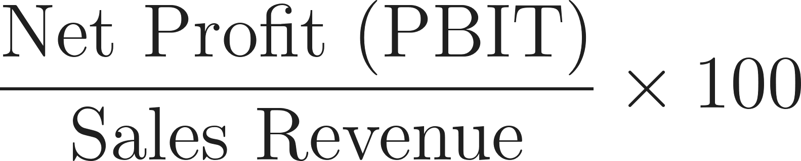 |  (Indicates high efficiency in managing both COGS and operating expenses, e.g., tech/high-value services). | 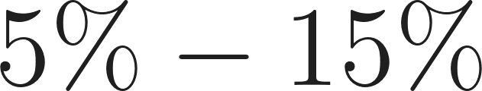 (A sustainable return, common across many stable industries). |  (Low returns; sensitive to minor cost changes and indicates potential overhead issues).
Return on Capital Employed (ROCE) | Measures the return generated by the total long-term capital invested in the business. It is the single most important measure of long-term efficiency for investors. | 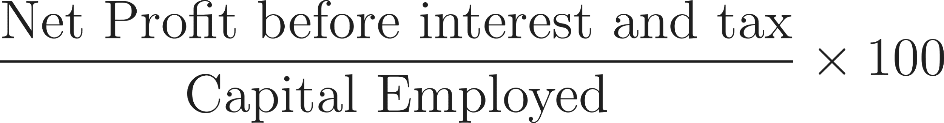    Or   | ROCE should exceed the firm’s cost of capital. | ROCE similar to industry average or marginally above cost of capital. | ROCE below the firm’s cost of capital indicates inefficient use of capital.

Liquidity and efficiency ratios
Ratio | Definition/Description | Formula | Good/Target | Acceptable/Contextual | Poor/Warning
Current Ratio | Measures a firm's ability to cover its short-term debts using its short-term assets. |  |  to  (Optimal balance of safety and avoiding idle assets). |  to  (Tight)  (Inefficient/too much idle cash/stock). |  (High illiquidity risk; current assets don't cover current liabilities).
Acid Test (Quick) Ratio | A stricter measure of liquidity; it excludes stock (inventory) from current assets, as inventory may be difficult to sell quickly. |  |  (Ideal solvency; can pay immediate debts without selling inventory). |  to  (Slight reliance on stock sales, but manageable). |  (Dangerous insolvency risk).
Stock Turnover (HL Only) | Measures the number of days a business sells and replaces its average level of stock. This formula calculates stock turnover in days. | Days: 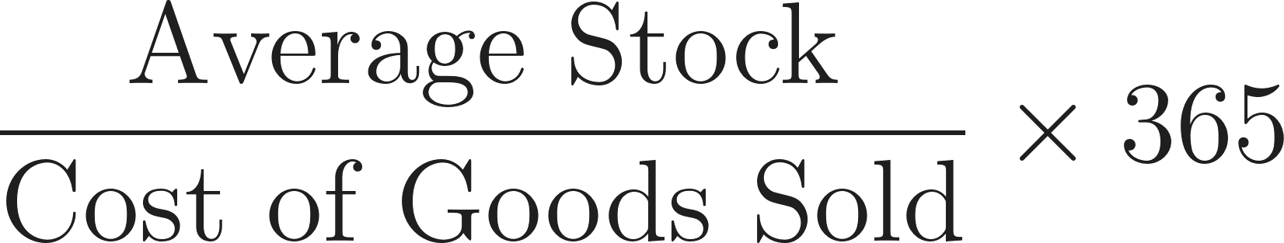  Times per year: 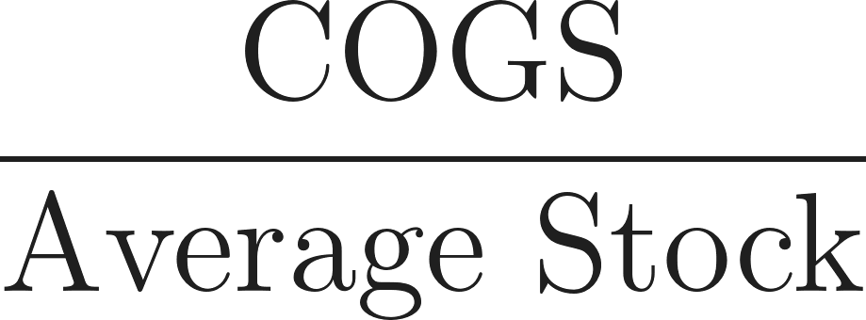 | Low Days (e.g., ): Efficient, low obsolescence risk (supermarkets/perishables). | Contextual: Varies widely (jewellery/aerospace can have higher days). | High Days (e.g., ): Excess inventory, high storage costs, slow sales.
Debtor Days (HL Only) | Measures the average time it takes for the business to collect payment from its credit customers. | 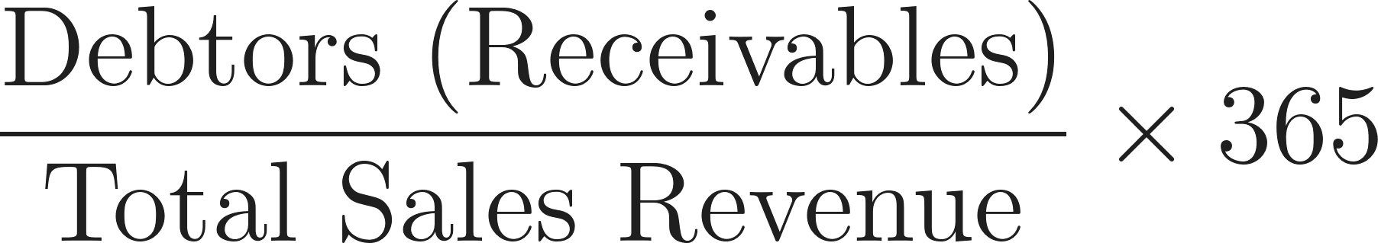 | Low (e.g.,  days): Efficient credit control. | Close to official credit period. | High (e.g.,  days): Poor cash flow, high risk of bad debts.
Creditor Days (HL Only) | Measures the average time it takes for the business to pay its suppliers. | 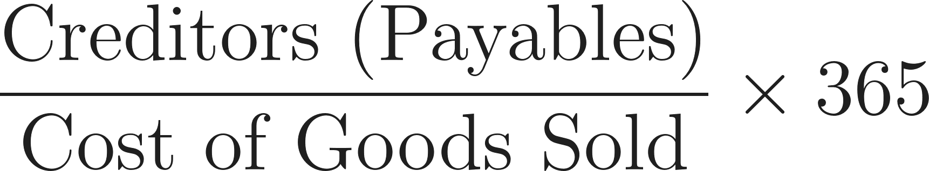 | High (e.g.,  days): Firm retains cash longer (good liquidity) without damaging relations. | Comparable to industry average. | Low (e.g.,  days): Paying too quickly, unnecessarily strains cash flow.
Gearing Ratio (HL Only) | Measures the proportion of a firm's long-term capital that is financed by debt (loan capital). Indicates financial risk. | 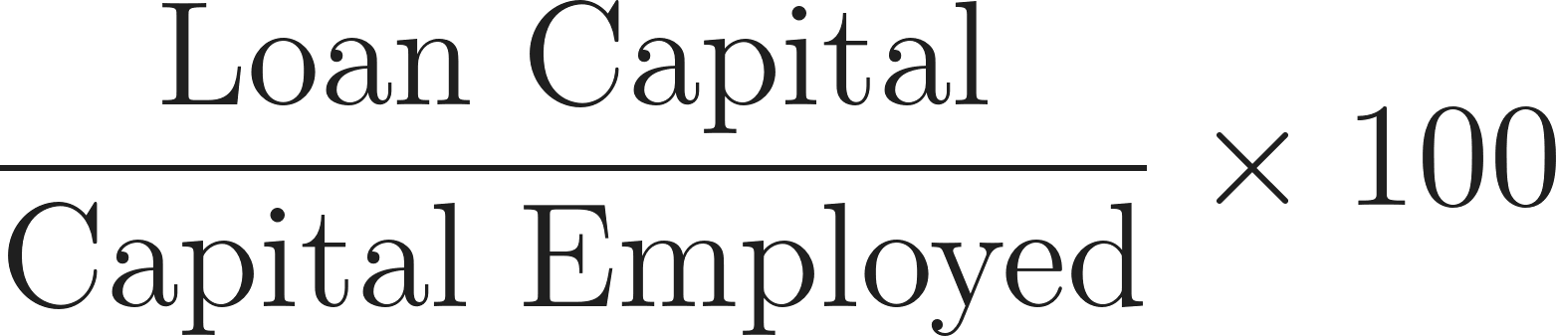 |  (Low risk, high capacity to borrow). | 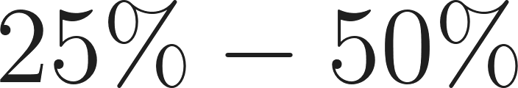 (Moderate risk; common for capital-intensive or expansion firms). |  (High risk, highly vulnerable to interest rate changes and recession).

Investment Appraisal Decision Criteria
Method | Definition/Description | Formula | Accept/Good Decision Criteria | Reject/Poor Decision Criteria
Payback Period | The time required for the total net cash inflows from an investment to equal the initial capital cost. Focuses on risk and quick return. | Count how many years until the last negative cumulative cash flow. Then to find months:  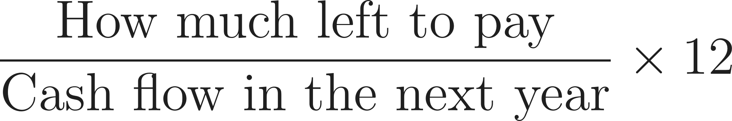 | Shortest period is preferred to allow for a margin of safety. | Close to the length of the project - no margin of safety re time.
Average Rate of Return (ARR) | The average annual profit of the investment expressed as a percentage of the initial cost. Used for quick profitability comparison. | 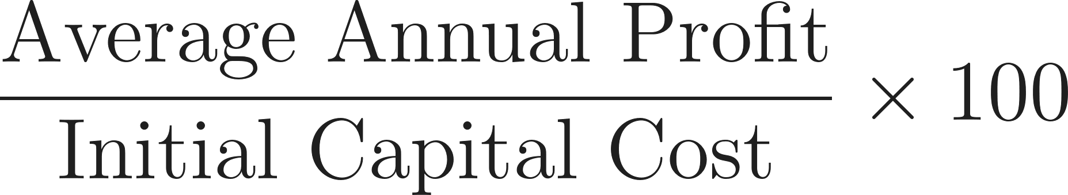  Check formula sheet for expanded average annual profit formula. | Highest percentage is preferred. Must be greater than the target rate/cost of capital.  Depends on what else firm could be using financial capital for, cost of borrowing. | Lower than the target rate/cost of capital.
Net Present Value (NPV - HL Only) | The sum of the present values of all cash flows (inflows and outflows) related to a project. Accounts for the time value of money. |  | Positive NPV (). Highest positive figure is preferred for comparison (creates shareholder value). | Negative NPV (). (Destroys value, should be rejected).

